9.001

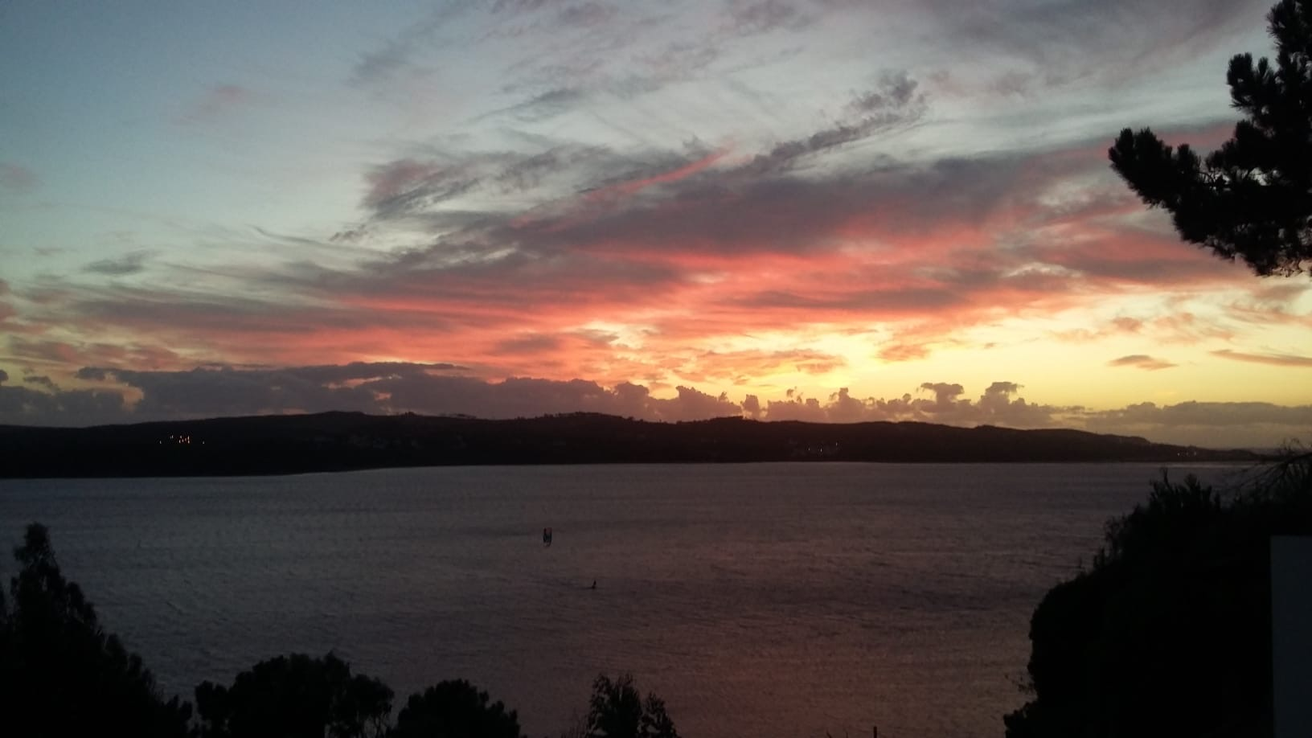

|  |  |
| --- | --- |
| 9.002 | 9.003 |

9.004

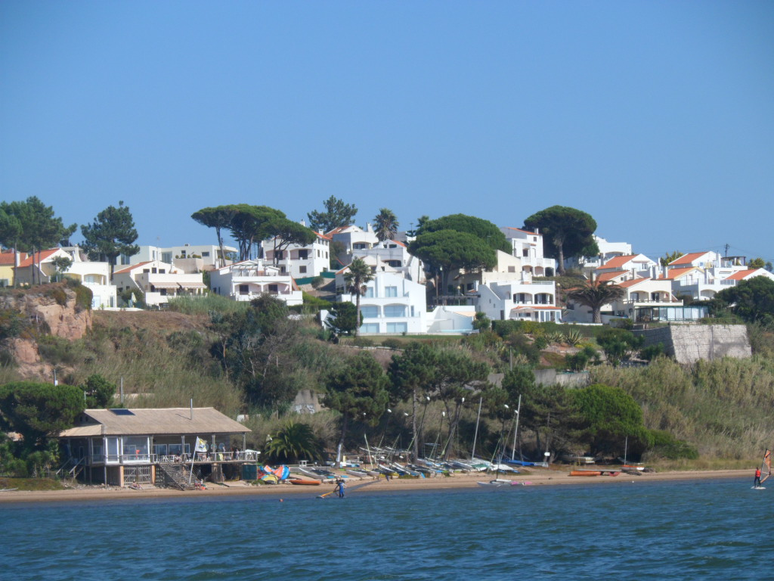

9.005

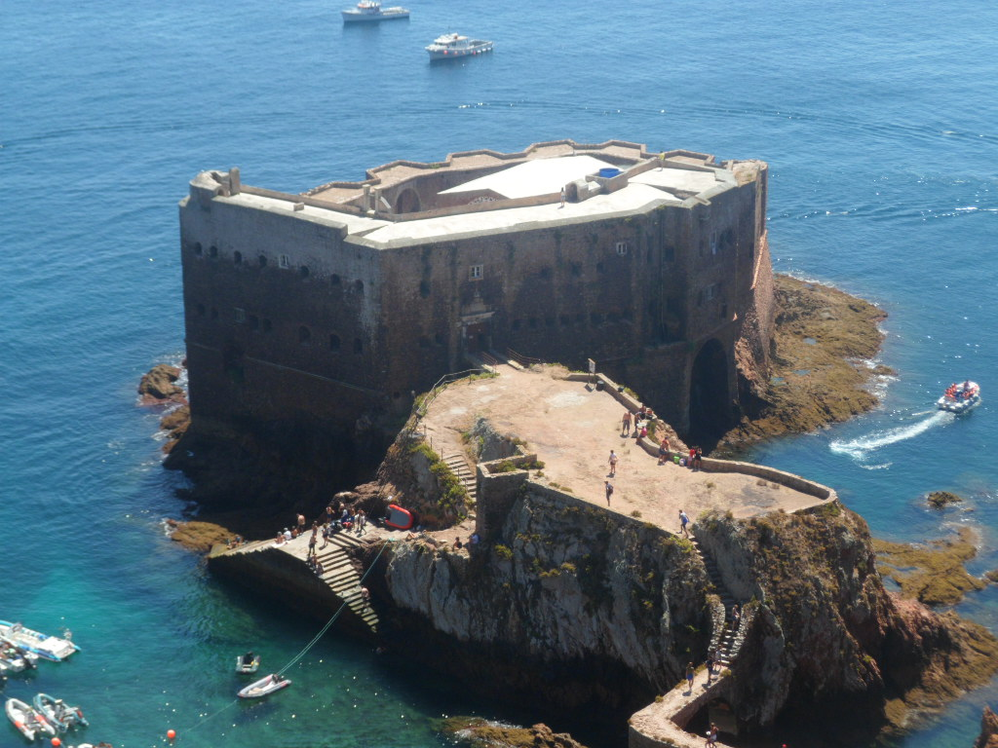

Ilha Berlenga